Campus Café Ordering System

Namo,Christ Angelou E.
Yren,Clevin L.
Object-Oriented Programming (java)
Section E

Introduction
The Campus Café Ordering System is a simple Java console‑based application built to demonstrate core Object‑Oriented Programming concepts. It simulates the ordering workflow for a campus café, handling customer orders that may include beverages, pastries, and meals. Each order can hold a maximum of three menu items. The system automatically computes the price for every item based on selected customizations such as drink sizes, heating for pastries, and extra sides for meals. It applies a 10 percent discount for student customers, accepts voucher deductions, and awards loyalty points depending on the customer’s final paid amount. The program also includes input validation to catch invalid entries like negative pricing, negative side counts, and adding more items than the order’s limit, showing error messages whenever invalid data is entered. This project serves as our laboratory exercise to show how OOP principles can be used to build a small, functional ordering system.

Program Structure
Our project is composed of seven separate Java classes. MenuItem is the abstract parent (super) class. Three subclasses Beverage, Pastry, and Meal inherit the properties and methods from MenuItem and implement their own unique pricing calculations through polymorphism. The Customer class keeps the customer’s basic information and their loyalty points. The Order class manages the list of menu items for each customer’s order, enforces the three‑item maximum limit, computes the subtotal, applies the student discount and voucher, and calculates the final total. Lastly, CafeApp is our main driver class containing the main() method that runs the whole program, creates test objects, triggers the validation checks, and prints the final console output for the café orders.

Program Output and Explanation
Ana Reyes is a student. Her order contains a large Iced Latte (₱120.00), a warmed Ensaymada (₱55.00), and an upsized Chicken Adobo with two extra sides (₱142.00). The subtotal is ₱317.00. After the 10% student discount of ₱31.70, her total is ₱285.30 and she earns 5 loyalty points. A fourth item is rejected because the order limit is three.
Ben Cruz orders a medium Hot Chocolate (₱95.00) and a regular Beef Tapa (₱130.00). His subtotal is ₱225.00. After the ₱20.00 voucher, his total is ₱205.00 and he earns 4 loyalty points.

Console Output
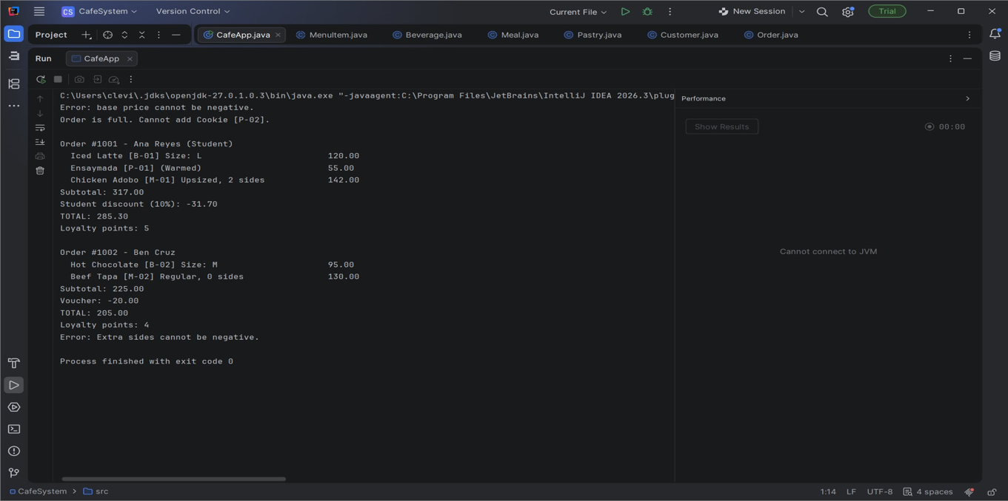

Challenges Encountered and Solution

One of the biggest challenges we faced was properly organizing the different Java classes and making sure all the objects communicated with each other correctly. I had to set up MenuItem as the abstract parent class, with Beverage, Pastry, and Meal as its child subclasses. The Order class had to store the customer’s details together with a limited list of up to three menu items. At first, the data from the menu items was not being passed properly to the order for total computation. I fixed this by carefully defining the class attributes, creating setter and getter methods, and properly instantiating each object inside the main application class.
Conclusion
This exercise helped me fully understand how Java Object‑Oriented Programming (OOP) concepts are applied to a working practical program. I learned how to create multiple classes and objects, link different objects together, protect data using encapsulation, reuse existing code through inheritance, and compute different pricing values with polymorphism. The finished program meets all the core requirements for the Campus Café Ordering System.

